1. **HOME PAGE**

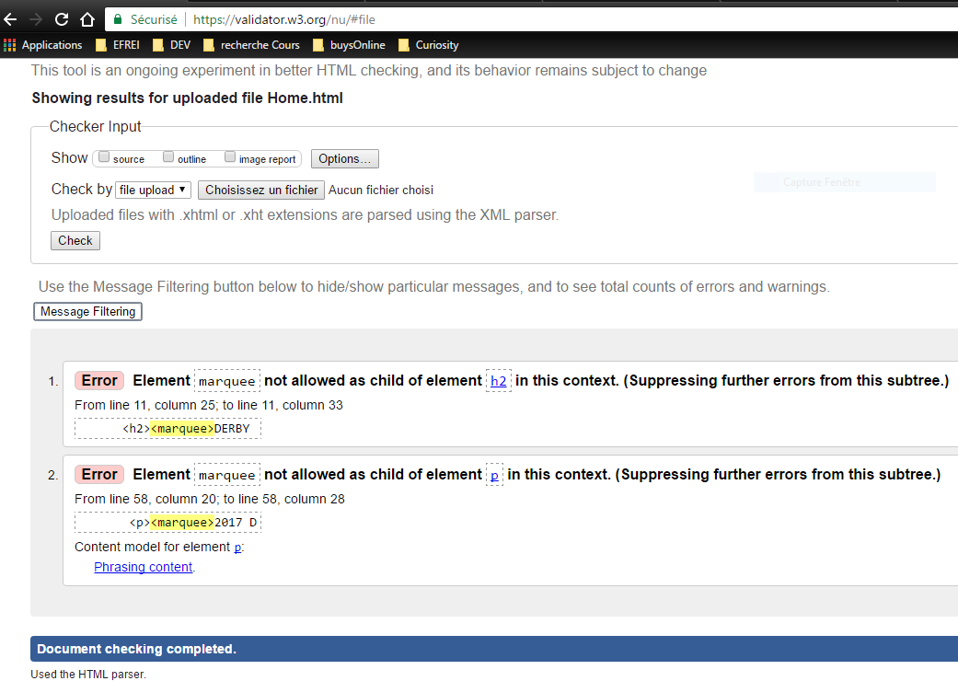

1. **DOG SEARCH PAGE**

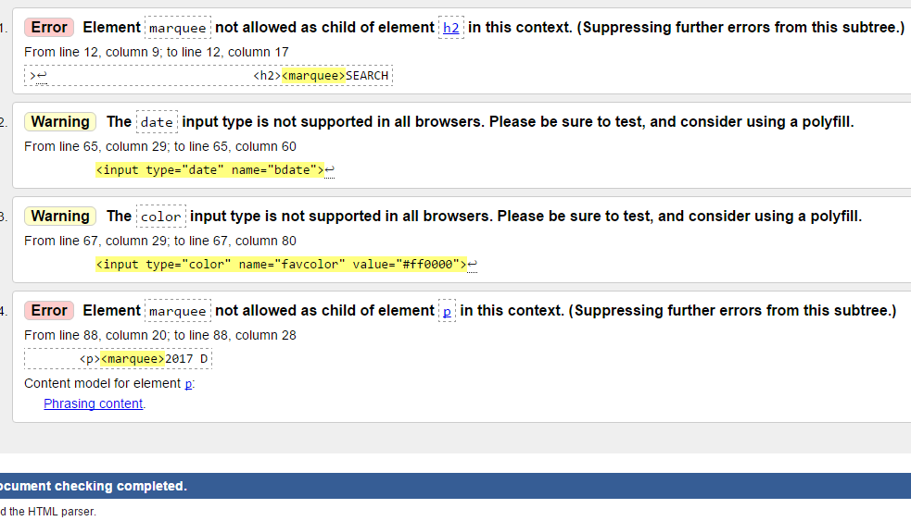

1. **SPONSOR A DOG PAGE**

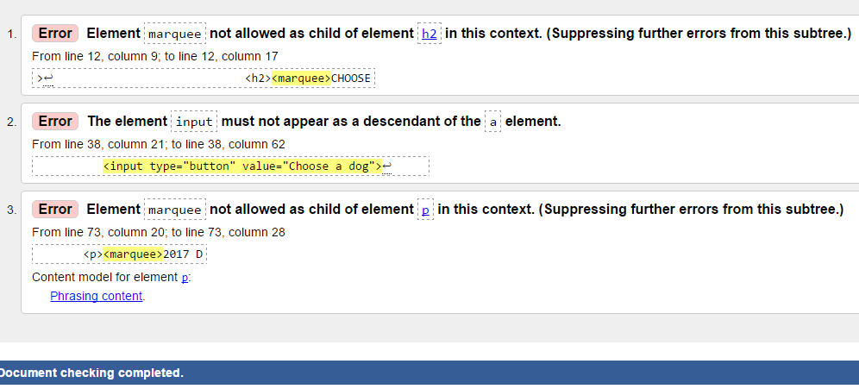

1. **ADMINISTRATOR PAGE**

